
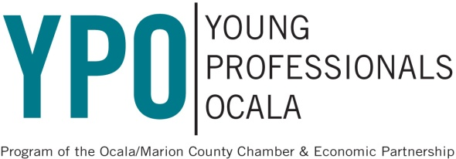
2018 Annual YPO Membership Application

First Name | Last Name
Date of Birth (Month/Day/Year) | Referred by (if applicable)
Mailing Address

City | Zip Code
Work Phone # | Cell Phone #
Occupation | Employer
E-mail Address (All communication is done by email)

Please check one:
- New member ($75)
- CEP Credit or Complimentary Membership based on my employer’s investment level
  - Credit
  - Complimentary
Company and Supervisor’s Name:

Method of Payment: (check one unless otherwise indicated above)

Check #________________ enclosed (payable to: Chamber & Economic Partnership)

Visa MasterCard Discover AMEX

Card Number #:

Expiration Date: Verification Code (on back of card):

Name on card:

Signature:

Your membership is for a one-year period.
Renewal invoices will be sent on the anniversary date of joining YPO.
Questions? Contact Andrea@OcalaCEP.com

